
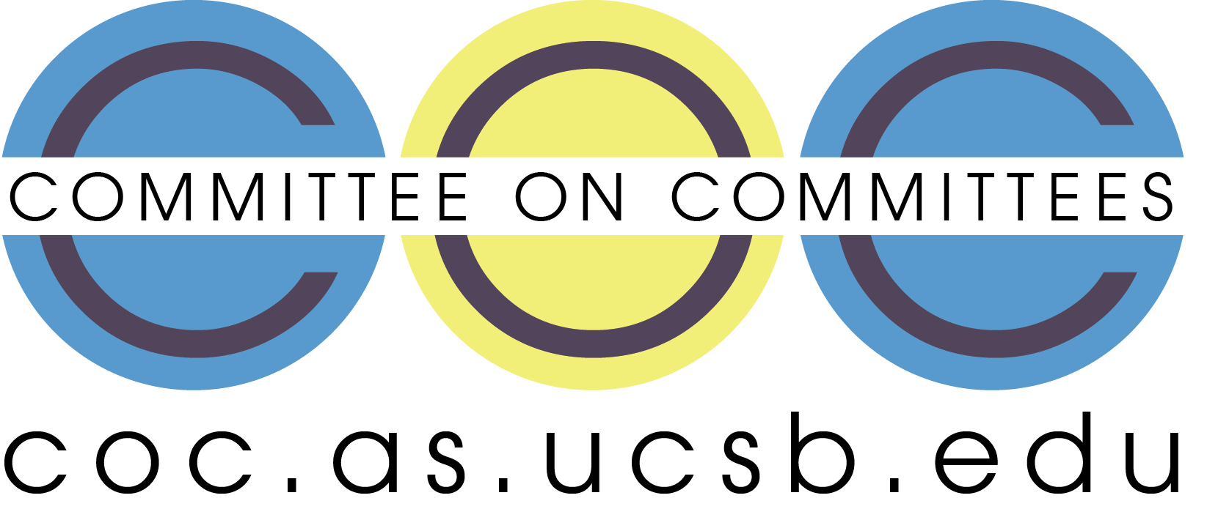

Committee on Committees Minutes

Associated Students
DATE: November 17th, 2025
LOCATION: Virtual (Zoom) Minutes/Actions recorded by: Shuyi Sum

CALL TO ORDER: 7:08pm by Lily Strange

QOTW: If Santa was real, what would you wish for this fall quarter?

A. MEETING BUSINESS

- Roll Call

Name | Note:  absent (excused/not excused)  arrived late (time)  departed early (time)  proxy (full name) | Name | Note:  absent (excused/not excused)  arrived late (time)  departed early (time)  proxy (full name)
Sophia Fei | Present | Yeshua Valdez Rodriguez | Present
Lily Strange | Present | Savanah Lizet Aldaba | Present
Shuyi Sum | Present | Adam Orenstein | ...
Oliver Ramirez Carrera | Present
Layla Hakim | Present
Mira Ikladious | Present

- Acceptance of Excused Absences

MOTION/SECOND: Last Name/Last Name
Motion Language: SAMPLE MOTION LANGUAGE
ACTION: Consent

- Acceptance of Proxies

B. PUBLIC FORUM

- EXTERNAL REPORTS

- Advisor’s Report

- Executive Officer’s Report(s)

- Group Project/Member Report(s)
  - Advisor and Senate Liaison Reports

Lily Strange - Internal Chair
    - CoC will welcome two Pearman Fellows in the winter!! Super super exciting.
      - We can have our Winter quarter retreat at the beginning so everyone can get to know each other and have team bonding
    - Update on current hirings:
      - Second president pro temp: interviewing, questions in the drive
        - Confirmed, we can send out emails
      - Senate Outreach: publicizing
        - I will do a umail announcement for these tn
    - Update on budget:
      - Please review this doc
        - Is someone available and willing to go to senate this wednesday (i’m in texas :P) to present this report
          - 6:30PM ucen
        - It was recommended we present this Weds
          - Also it would be right after quarter reports so we can wow wow them tuesday and then ask for $$$ wednesday
    - Oliver - checking in / second internal liaison position
      - HRB has their form closed
      - TQComm has their form closed
      - Maybe we can send one last wrap up email so we know for sure if their positions are filled? And check in with all others that are open rn (except senate outreach and second pres pro temp)
    - Website
      - Closed positions / updated the website
    - Coffee with the pres tomorrow 2pm-4pm:
      - Oliver are you still good to go tomorrow
      - We are advertising for senate leadership and senate outreach
    - Transfer student event tomorrow 12:30-1:30pm
      - Sophia, Layla, Oliver
      - CoC’s slides → can one of you three fill these in for when you guys go
      - Two people is probably enough? Oliver if you want to just do the coffee with the pres
    - Quarter report → take a peek 💃 (slide 38)

Sophia Fei - External Chair
    - State of the association tmw 6-8:30 corwin pavilion
    - Emailing and interview docs
    - 2 Interviews this friday
    - Yes retreat
      - Chilis?????
      - Ice skating
      - bowling
    - TSA tabling tomorrow 12-2 (Kerr Hall 1120, Transfer Student Center)

Shuyi Sum - Vice Chair
    - Organizing Office of Senate apps/interviews…
      - CoC Fall 2025 Interview Schedules lmk if you can’t make it to one you’re assigned to ASAP
      - Make sure that Melanie gets the zoom link !! (as-mjones@as.ucsb.edu)
    - We need to vote on Fall retreat (Confirm Dec 1st?)

Oliver Ramirez Carrera - Internal Liaison
    - First Campus Election Commission meeting
      - CEC is responsible for facilitating the process of getting things on the ballet
        - A lot to due with quarterly fees, if they pass through CEC then the general student population gets to vote these issues
      - Serving as A.S. representative
      - Appointed CEC student chair
    - Completed A.S. make-up attendance
    - Having coffee with the president on Tuesday 2-4 at the arbor
    - Interview on Friday
    - Send wrap-up email to BCUs on the spreadsheet scheduled for week 10

VACANT - Internal Liaison

Layla Hakim - Outreach and Recruitment Coordinators
    - QOTW: straight A’s 😭
    - Tabling at the transfer student event on Friday
      - Will update the open position fliers and reprint
      - Will fill out the slides as well
    - Many emails have been sent out for the office of the senate which I think helped gain traction (aka our interviews yay!)
      - Mira idk if you got my text but Polisci is asking for a flier to post on their insta instead, did you happen to make one or should I?
    - Will interview Lila this Friday!
    - Emails for:
      - Office of senate outreach committee
      - Book bank

Mira Ikladious - Outreach and Recruitment Coordinators
- QOTW: A on bio midterm
- Pro temp post
- Have contacted many other BCUs about promos for open positions
- Idk what the poli sci flyer is but I'd be happy to do it!!
- Office of the Senate + foodbank INSTA POST

Yeshua Valdez Rodriguez - Outreach and Recruitment Coordinators
    - Thank you, Lily, for connecting me with Alex
      - Alex proposed the idea of having our website homepage be more for recruitment advertising rather than having it as a hub where we showcase overall past events, given that the regular A.S website seems to already do that and have plans to do that https://www.as.ucsb.edu/
      - ^ His point was that we should try to market ourselves as a place of recruitment
      - Alex proposed something like Handshake’s homescreen (past events could be featured here)
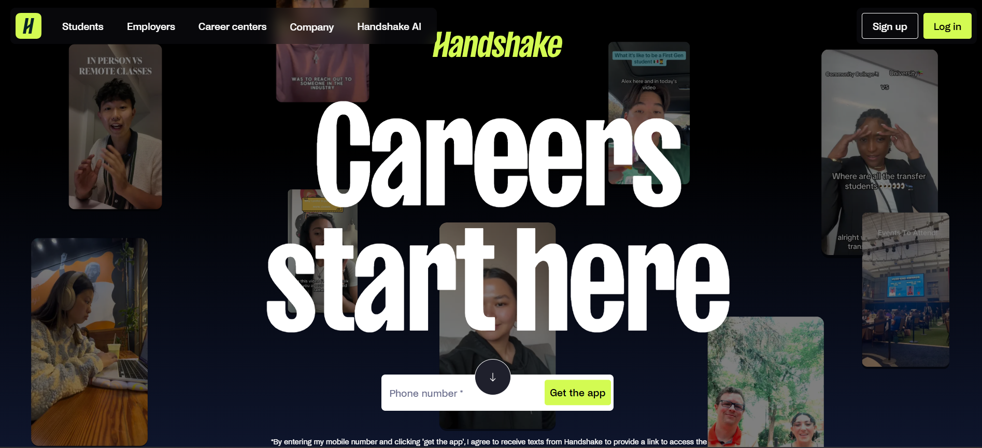
      - "Find your fit" form would have to take place after the whole restructure of the website
      - I’ve also talked to Alex about having a more streamlined open positions page where he will have open positions at the top in a better template that's more modern. I still requested that we have a drop-down menu of closed committees so students can see what could be offered in the future
      - We also talked about fixing our search tab
      - Alex said that fixing the “APPLY!” button would take up most of his time (I’ll explain in the meeting)
      - Lastly, I proposed the idea of changing CoC Resources to include a photo headshot, bio, and contact information for a more professional look. Alex says it wouldn’t be hard
    - Professional Headshots
      - We would have to provide professional headshots for Alex to put on the CoC resources.
      - I have a photographer who can take the photos for us, he just wants to know our budget
      - Here are some of his previous works: https://drive.google.com/drive/folders/11YAd5iXVmeFNywGlLph4lwGGBcno_bJv?usp=sharing
      - Let me know if this would be something y'all would like to do
    - I kinda want to make a video for the website or Instagram in VOX POP style, interviewing A.S members about their experiences
    - I can help get alumni Charlie Arreola Student Body President for A.S from 2009-2010
    - I will be attending senate this wednesday
    - I will be interviewing Mohammad this wednesday as well

Savanah Lizet Aldaba - Outreach and Recruitment Coordinators
    - QOTW: A’s on my midterms.
    - Attended Book Banks Meeting, they need help advertising for book bank services and volunteers. A lot of people have never heard of them or are unaware of their services.
    - Interviewing Isabella, Samrita, and Mohammad this week.

Adam Orenstein - Commissioner of Community and Climate

C. Action Items

- ACCEPTANCE of AGENDA/CHANGES to AGENDA

- CONSENT ITEMS

- Approval of our Action Summary/Minutes from:

- ACTION ITEMS

F-1. Old Business:

F-2 New Business:

- DISCUSSION ITEMS

- Discussion Topic

- REMARKS

- ADJOURNMENT

MOTION/SECOND: Oliver/Mira
Motion Language: I motion to adjourn this meeting at 7:39pm on November 17th.
ACTION: CONSENT

